Capacity Grid Digital Display Calipers Working Principle Author Huang Heian (作者 黄鹤年)

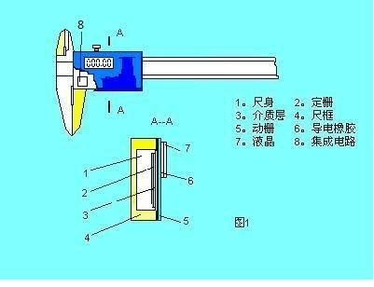

Capacitive gate sensor

Capacity Grid Digital Display Calipers Working Principle (1)

The use of capacitive sensors of electronic digital caliper in China, there have been more than 10 years of history. The first draft of this paper was written more than a decade ago. According to the information of the domestic chip supplier and the actual calculation, the mechanical displacement and the phase of the output signal were calculated by the ordinary complex calculation of the resistance and capacitance of the AC circuit. The basis of error analysis. Now reorganized out for interested parties reference and exchange.

The so-called modulation and demodulation, is the useful signal and do not interfere with the interference of the signal measures, was widely used in telecommunications technology. In order to be able to transmit a number of different channels in a telephone line, the telephone signals of each channel are modulated to distinguish them from each other. We are most familiar with the Internet is the use of the modem and radio, TV is modulated by the signal and then sent out. And then the original signal demodulation back. Which has amplitude modulation, FM and so on. Also in the mechatronic length measurement technology, such as grating and induction synchronizer sensors are mostly used in phase modulation method for length measurement. Especially inductive synchronizers and capacitive sensors are very similarities. In the induction synchronizer, there are two sets of excitation windings on the slider, separated by a certain distance, respectively, the application of sinusoidal and cosine voltage, they are in the fixed winding on the total induced potential of the initial phase contains time-independent mechanical displacement X information. The difference is that the capacitive gate sensor uses a capacitor and a 8-phase phase difference is applied with an increasing sinusoidal voltage of 45 degrees. This sinusoidal voltage is generated by the clock oscillator by the frequency divider generated by the periodic abnormal square wave, the fundamental component is a sine wave. If there is no AC signal as a carrier, then the mechanical displacement information is difficult to transfer. So here only need to use the AC circuit in the complex number of calculation method is sufficient, but the formula is too long, and sometimes the numerator and denominator to separate to write. Since it is phase modulation, then the phase detector is a demodulator. Of course, there are different ways to distinguish the function of the included in the circuit. This paper mainly analyzes the principle of capacitance displacement measurement.

The structure of a digital caliper

Figure 1 is a schematic representation of the caliper structure.

The main gate is a fixed sensor element 2, it is attached to the body feet. Moving the gate 5, and it is coupled foot block, and moves with the foot frame. The capacitance between the moving grids varies with its relative displacement according to certain laws. 6 Group 8 of the driving AC voltage

Under the action, in the receiver board output an AC voltage signal, the phase is a function of the amount of mechanical displacement x. It exhibits a linear function at a certain precision. So that in this phase modulation and demodulation process to achieve accurate measurement of length, and in the LCD display readings.

two. Measuring circuit principle

As shown in the following figure, the circuit board has a clock oscillator, resulting in clock pulse square wave, the so-called frequency, that is, periodically broaden the square wave or valley, resulting in abnormal square wave, the fundamental wave is sine wave. There are 8 shots, each applied sinusoidal voltage initial phase in 45 degrees (π / 4) increments in increments, the 8-channel signal applied to each group of 8 moving grid slats, a total of 6 groups (corresponding 48 bar). Receiver board output signal is also a sine wave voltage, the frequency and the input signal is the same, the initial phase angle is a function of dynamic gate mechanical displacement, approximate linear changes. Produced by displacement x

The relationship between the AC voltage phase and x is approximately linear, and the output phase value is converted to digital display by the integrated circuit. The displayed number is the displacement value.

Next (2)

Capacity Grid Digital Display Calipers Working Principle (1)

The use of capacitive sensors of electronic digital caliper in China, there have been more than 10 years of history. The first draft of this paper was written more than a decade ago. According to the information of the domestic chip supplier and the actual calculation, the mechanical displacement and the phase of the output signal were calculated by the ordinary complex calculation of the resistance and capacitance of the AC circuit. The basis of error analysis. Now reorganized out for interested parties reference and exchange.

The so-called modulation and demodulation, is the useful signal and do not interfere with the interference of the signal measures, was widely used in telecommunications technology. In order to be able to transmit a number of different channels in a telephone line, the telephone signals of each channel are modulated to distinguish them from each other. We are most familiar with the Internet is the use of the modem and radio, TV is modulated by the signal and then sent out. And then the original signal demodulation back. Which has amplitude modulation, FM and so on. Also in the mechatronic length measurement technology, such as grating and induction synchronizer sensors are mostly used in phase modulation method for length measurement. Especially inductive synchronizers and capacitive sensors are very similarities. In the induction synchronizer, there are two sets of excitation windings on the slider, separated by a certain distance, respectively, the application of sinusoidal and cosine voltage, they are in the fixed winding on the total induced potential of the initial phase contains time-independent mechanical displacement X information. The difference is that the capacitive gate sensor uses a capacitor and a 8-phase phase difference is applied with an increasing sinusoidal voltage of 45 degrees. This sinusoidal voltage is generated by the clock oscillator by the frequency divider generated by the periodic abnormal square wave, the fundamental component is a sine wave. If there is no AC signal as a carrier, then the mechanical displacement information is difficult to transfer. So here only need to use the AC circuit in the complex number of calculation method is sufficient, but the formula is too long, and sometimes the numerator and denominator to separate to write. Since it is phase modulation, then the phase detector is a demodulator. Of course, there are different ways to distinguish the function of the included in the circuit. This paper mainly analyzes the principle of capacitance displacement measurement.

The structure of a digital caliper

Figure 1 is a schematic representation of the caliper structure.

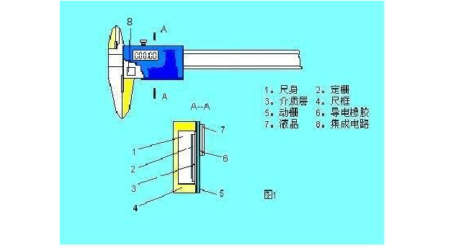

The main gate is a fixed sensor element 2, it is attached to the body feet. Moving the gate 5, and it is coupled foot block, and moves with the foot frame. The capacitance between the moving grids varies with its relative displacement according to certain laws. In the 6 groups of 8-way AC voltage under the action of the receiving board output an AC voltage signal, the phase is a function of the amount of mechanical displacement x. It exhibits a linear function at a certain precision. So that in this phase modulation and demodulation process to achieve accurate measurement of length, and in the LCD display readings.

two. Measuring circuit principle

As shown in the following figure, the circuit board has a clock oscillator, resulting in clock pulse square wave, the so-called frequency, that is, periodically broaden the square wave or valley, resulting in abnormal square wave, the fundamental wave is sine wave. There are 8 shots, each applied sinusoidal voltage initial phase in 45 degrees (π / 4) increments in increments, the 8-channel signal applied to each group of 8 moving grid slats, a total of 6 groups (corresponding 48 bar). Receiver board output signal is also a sine wave voltage, the frequency and the input signal is the same, the initial phase angle is a function of dynamic gate mechanical displacement, approximate linear changes. Produced by displacement x

The relationship between the AC voltage phase and x is approximately linear, and the output phase value is converted to digital display by the integrated circuit. The displayed number is the displacement value.

Next (2)

two. Circuit principle (integrated circuit chip)

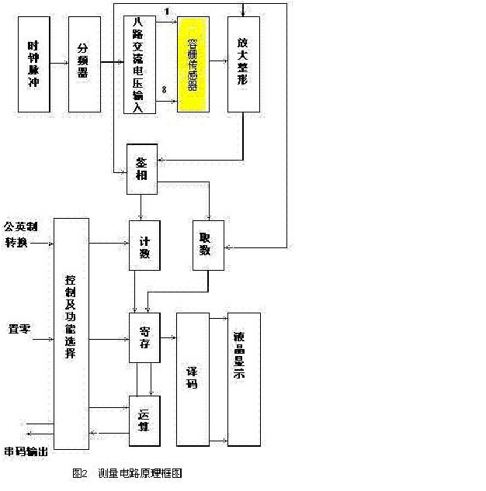

three. Dynamic grid and the grid size and the mutual position between them (in the figure in mm)

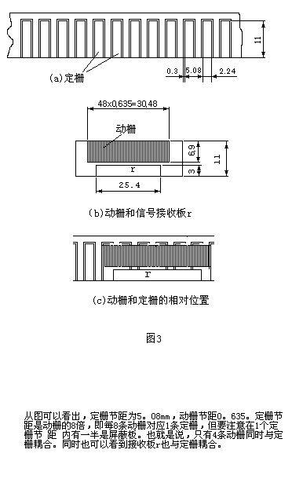

In addition, the receiving plate r is coupled to the grating, which is 25.4 mm long. Because the pitch is 5.08mm, so 25.4 / 5.08 = 5, that is, the receiver board and 5-section grid coupling. This data will be used in the calculation formula, hereby emphasize.

four. Mechanical structure and electrical signal transmission process in capacitive sensor

In the figure, e1 (t), e2 (t) ... e8 (t) represent the 8-ac AC voltage generated by the clock pulse, and the initial phase angle is incremented by 45 degrees. Respectively, to the adjacent eight dynamic grid plate. The figure shows only the first group, the other groups and the first group of the same. (6x8 = 48), the receiver board length 25.4 corresponds to the five groups of coupling.

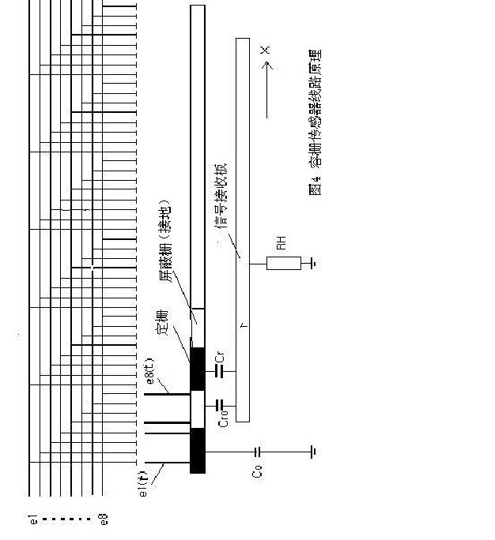

Take the next one

four. Mechanical structure and electrical signal transmission process in capacitive sensor

In the figure, e1 (t), e2 (t) ... e8 (t) represent the 8-ac AC voltage generated by the clock pulse, and the initial phase angle is incremented by 45 degrees. Respectively, to the adjacent eight dynamic grid plate. The figure shows only the first group, the other groups and the first group of the same. (6x8 = 48), the receiver board length 25.4 corresponds to the five groups of coupling.

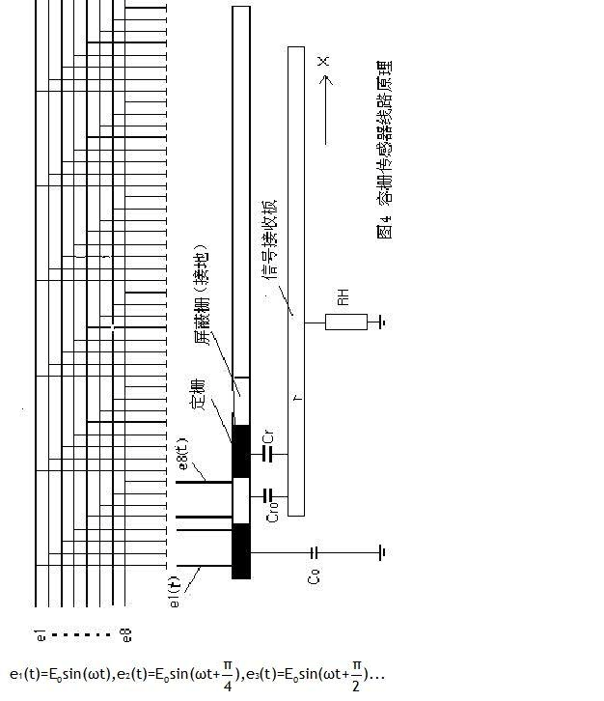

Take the next one

Fives. 8-way drive voltage source - periodic abnormal square wave

Let τ be 5.5μsec, that is, the clock pulse period. The deformed square wave period T = 512τ. (Most small square wave periods in the figure are estimated to be 16 τ)

The first half of the period of convex malformations, the latter half of the period for the concave deformity. Its fundamental wave for the sine wave, followed by 45 degrees to increase the initial phase:

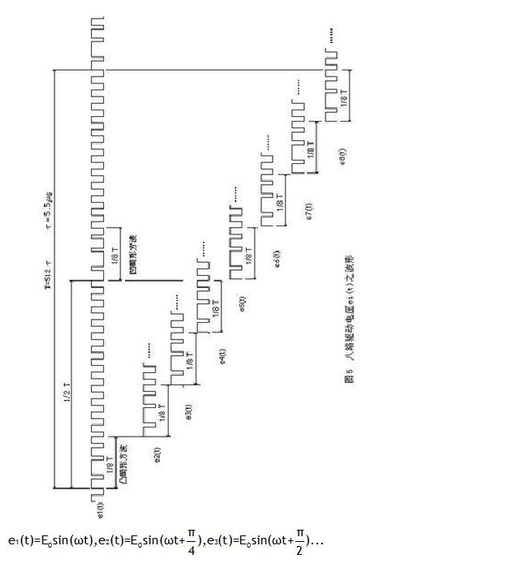

Fives. 8-way drive voltage source - periodic abnormal square wave

Let τ be 5.5μsec, that is, the clock pulse period. The deformed square wave period T = 512τ. (Most small square wave periods in the figure are estimated to be 16 τ)

The first half of the period of convex malformations, the latter half of the period for the concave deformity. Its fundamental wave for the sine wave, followed by 45 degrees to increase the initial phase:

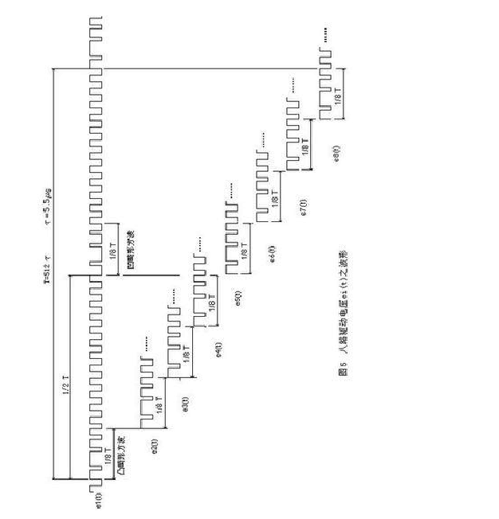

six. Driving voltage phase vector

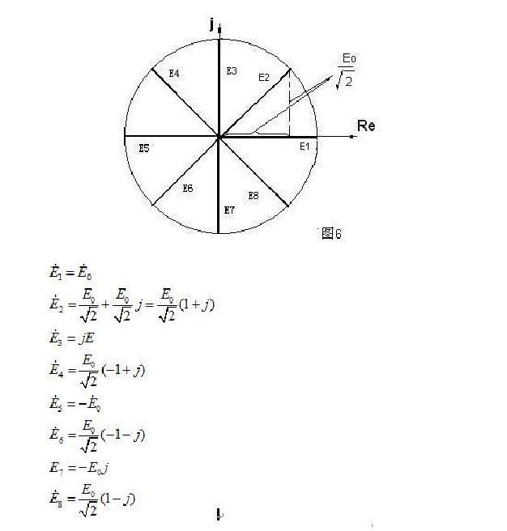

Seven. Equivalent circuit diagram

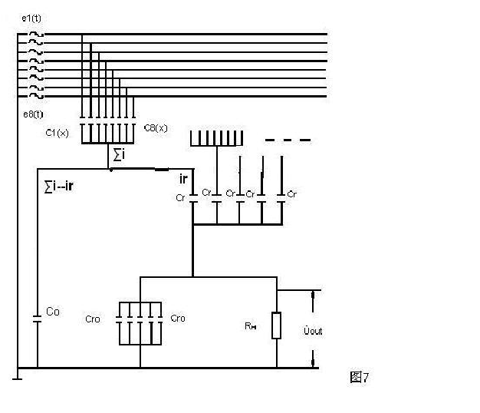

Eight. The dynamic grid capacitance varies with displacement x

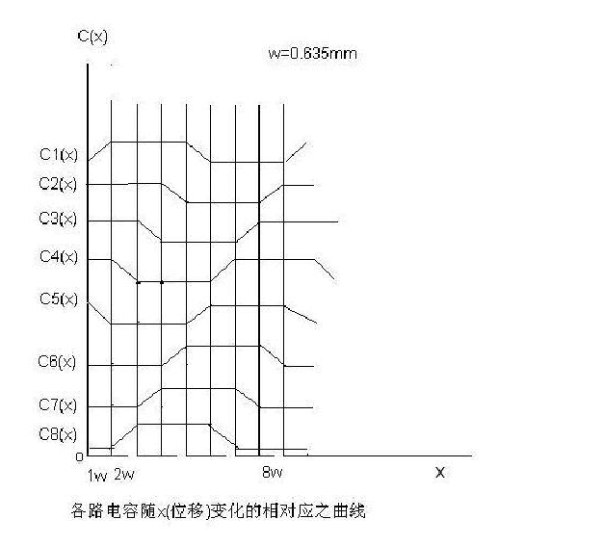

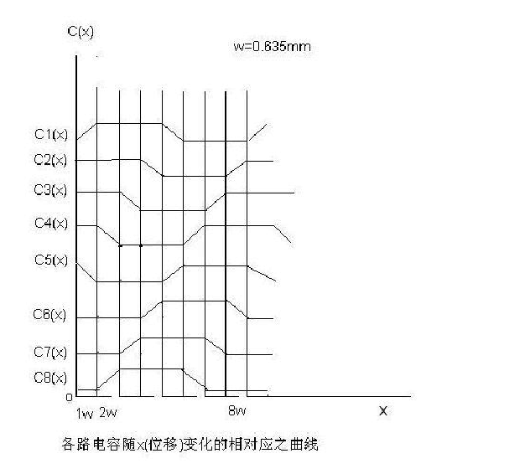

Eight. The dynamic grid capacitance varies with displacement x

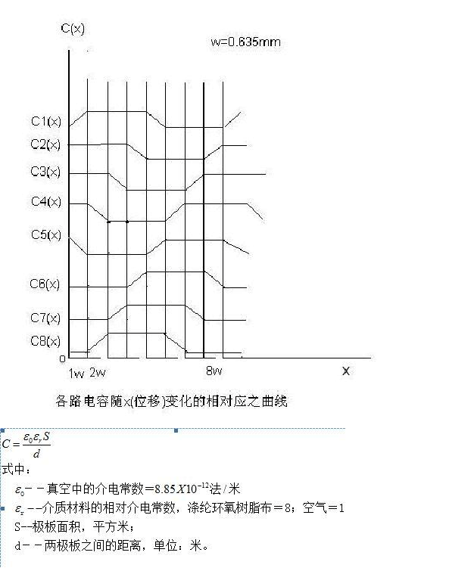

start calculating

The general formula of parallel plate capacitance calculation

1) Cr - the coupling plate to a fixed grid of the coupling capacitor, the media for the air + polyester, the thickness of each 0.1mm, a total of 0.2mm: that

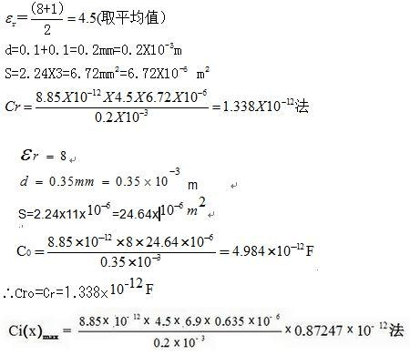

2) C0 ... capacitance between the fixed grid and the ruler (ground).

Because the thickness of the fixed-clad foil is 0.35mm, the substrate is epoxy resin

3) Cro ... Capacitance between receiving plate and shielded ground plate. As the size of the shield plate and the same fixed grid, the board between the same distance

4) C1 (x), C2 (x) ... to C8 (x) The capacitance between each grid and the grid. They are functions of the mechanical displacement x, sometimes zero, sometimes oblique

The function Kx, sometimes the maximum value of KW (constant). As shown in Fig. 8, since it is a discontinuous line, the capacitance value of each corresponding time must be calculated in stages.

When the dynamic bar is fully coupled with the grid,

Suppose that the coupling capacitance between the movable grid and the fixed gate is K per millimeter width

K = Ci (x) max / 0.635 == 1.37397x10 ^ (- 12) method / mm

W = 0.635mm Originally the dynamic gate pitch, in order to calculate the convenience, to replace the board width, the error will not be great. For simplicity, use Ci instead of Ci (x). As can be seen from Figure 8:

start calculating

The general formula of parallel plate capacitance calculation

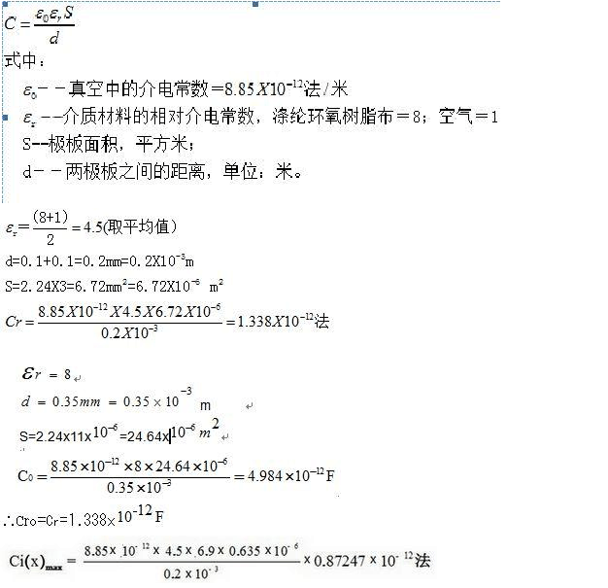

1) Cr - the coupling plate to a fixed grid of the coupling capacitor, the media for the air + polyester, the thickness of each 0.1mm, a total of 0.2mm: that

2) C0 ... capacitance between the fixed grid and the ruler (ground).

Because the thickness of the fixed-clad foil is 0.35mm, the substrate is epoxy resin

3) Cro ... Capacitance between receiving plate and shielded ground plate. As the size of the shield plate and the same fixed grid, the board between the same distance

4) C1 (x), C2 (x) ... to C8 (x) The capacitance between each grid and the grid. They are functions of the mechanical displacement x, sometimes zero, sometimes oblique

The function Kx, sometimes the maximum value of KW (constant). As shown in Fig. 8, since it is a discontinuous line, the capacitance value of each corresponding time must be calculated in stages.

When the dynamic bar is fully coupled with the grid,

Suppose that the coupling capacitance between the movable grid and the fixed gate is K per millimeter width

K = Ci (x) max / 0.635 == 1.37397x10 ^ (- 12) method / mm

W = 0.635mm Originally the dynamic gate pitch, in order to calculate the convenience, to replace the board width, the error will not be great. For simplicity, use Ci instead of Ci (x). As can be seen from Figure 8:

I. When 0 ≤ x ≤ W, the capacitance values ​​of the strip are respectively

C1 = Kx

C2 = C3 = C4 = KW

C5 = K (Wx)

C6 = C7 = C8 = 0

Ii. When W ≤ x ≤ 2W

C1 = C2 = C3 = KW

C4 = K (2W-x)

C5 = C6 = C7 = 0

C8 = K (xW)

Iii. When 2W ≤ x ≤ 3W

C8 = C1 = C2 = KW

C3 = K (3W-x)

C4 = C5 = C6 = 0

C7 = K (x-2W)

Iv. When 3W ≤ x ≤ 4W

C7 = C8 = C1 = KW

C2 = K (4W-x)

C3 = C4 = C5 = 0

C6 = K (x-3W)

The rest and so on.

It can also be seen from Fig. 4 that when x is any value, there are always a part of the 48 plates on the movable grid forming a capacitance with the ground (shield). The corresponding input signal directly into the ground, the sensor output signal does not have an impact. In the calculation can be the capacitor as zero.

There are six groups of plates on the grid, the work of each group are the same, so one of the groups to be analyzed. Each group of eight emitter plates, each received from the drive circuit to send the square wave signal or the fundamental sine signal e1 (t), e2 (t) ... e8 (t), called the 8-way drive signal. They are incremented by 45 degrees in sequence. The shape of the drive signal is special, and it is also called the mark pulse (Figure 5). The period of this signal is T = 512τ = 2816 sec. A wide convex wave at the beginning of 1/8 T, and a wide concave wave at the beginning of the beginning of 1/2, so that the fundamental wave over the entire T cycle is a sinusoidal signal. So take it as a sine wave. In fact the measured waveform is also a sine wave. (T) = Esin (ωt + π / 2) ... ... they are the calculus we calculate. Let us write e1 (t) = Esin (ωt), e2 (t) = Esin (ωt + π / 4), e3 (t) = Esin (ωt + π / 2) Voltage source, each circuit is an AC circuit, you can use Keshchov first and second law to write the equivalent circuit in the current and voltage equations, they are:

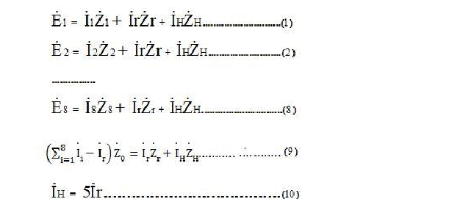

I. When 0 ≤ x ≤ W, the capacitance values ​​of the strip are respectively

C1 = Kx

C2 = C3 = C4 = KW

C5 = K (Wx)

C6 = C7 = C8 = 0

Ii. When W ≤ x ≤ 2W

C1 = C2 = C3 = KW

C4 = K (2W-x)

C5 = C6 = C7 = 0

C8 = K (xW)

Iii. When 2W ≤ x ≤ 3W

C8 = C1 = C2 = KW

C3 = K (3W-x)

C4 = C5 = C6 = 0

C7 = K (x-2W)

Iv. When 3W ≤ x ≤ 4W

C7 = C8 = C1 = KW

C2 = K (4W-x)

C3 = C4 = C5 = 0

C6 = K (x-3W)

The rest and so on.

It can also be seen from Fig. 4 that when x is any value, there are always a part of the 48 plates on the movable grid forming a capacitance with the ground (shield). The corresponding input signal directly into the ground, the sensor output signal does not have an impact. In the calculation can be the capacitor as zero.

There are six groups of plates on the grid, the work of each group are the same, so one of the groups to be analyzed. Each group of eight emitter plates, each received from the drive circuit to send the square wave signal or the fundamental sine signal e1 (t), e2 (t) ... e8 (t), called the 8-way drive signal. They are incremented by 45 degrees in sequence. The shape of the drive signal is special, and it is also called the mark pulse (Figure 5). The period of this signal is T = 512τ = 2816 sec. A wide convex wave at the beginning of 1/8 T, and a wide concave wave at the beginning of the beginning of 1/2, so that the fundamental wave over the entire T cycle is a sinusoidal signal. So take it as a sine wave. In fact the measured waveform is also a sine wave. So write them

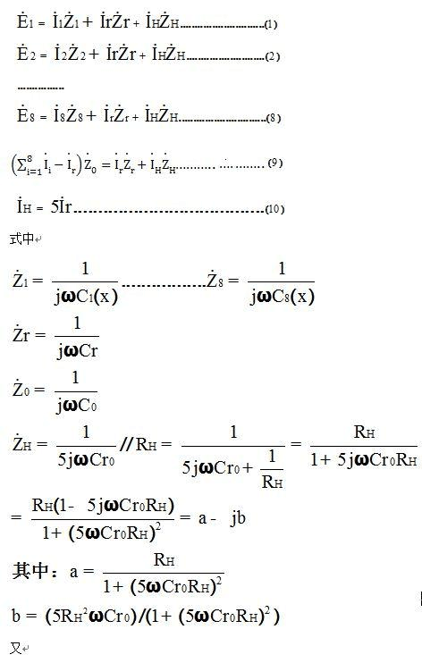

E3 (t) = Esin (ωt + π / 2) ... They are the AC voltage sources we calculate The circuit is the AC circuit, can be used Keshi Hough first and second law to write the equivalent circuit in the current and voltage equations, they are:

2011-01-03 00:50

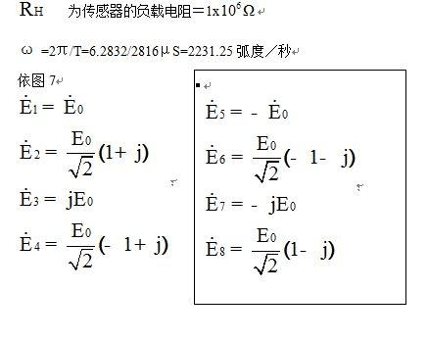

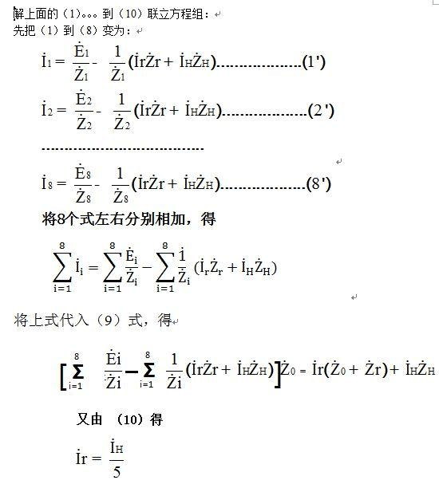

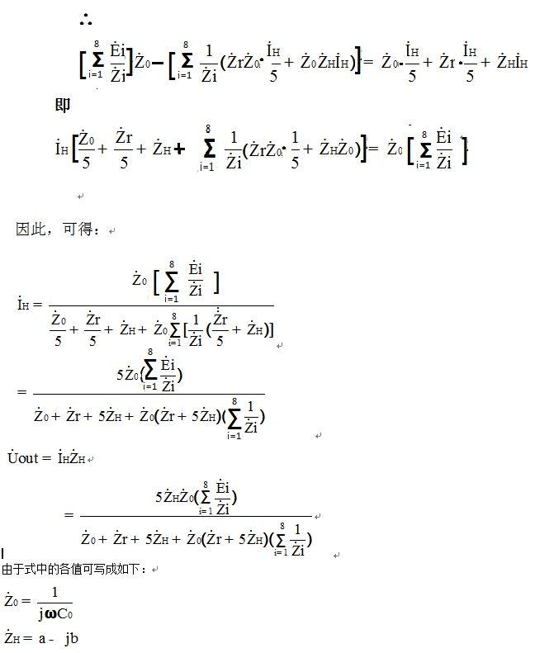

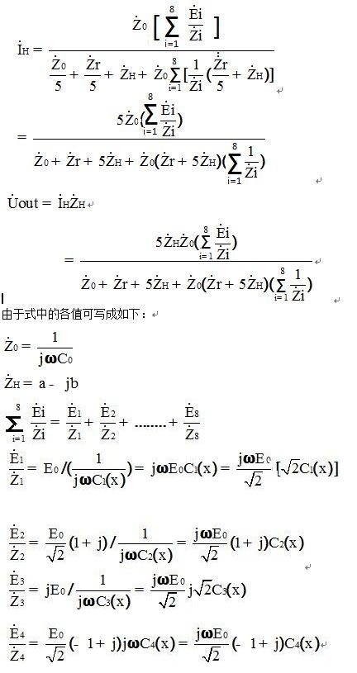

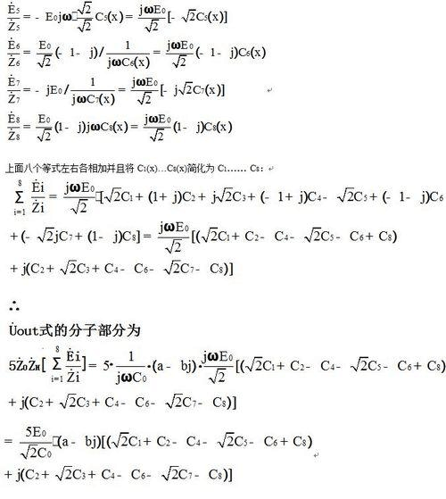

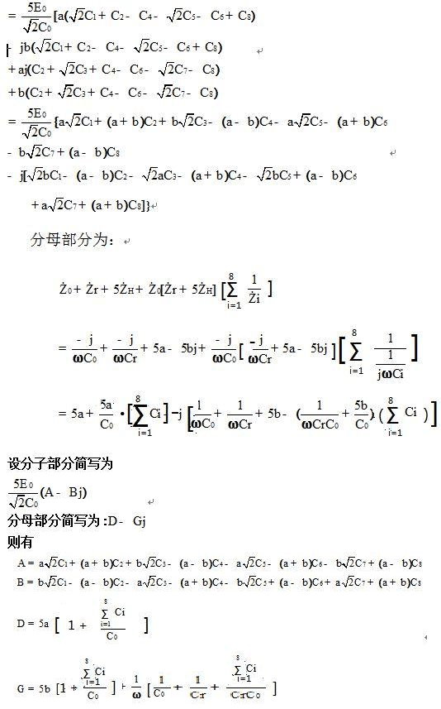

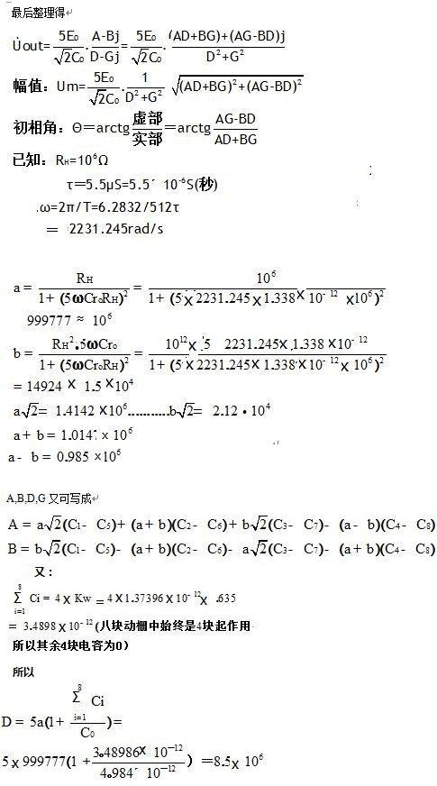

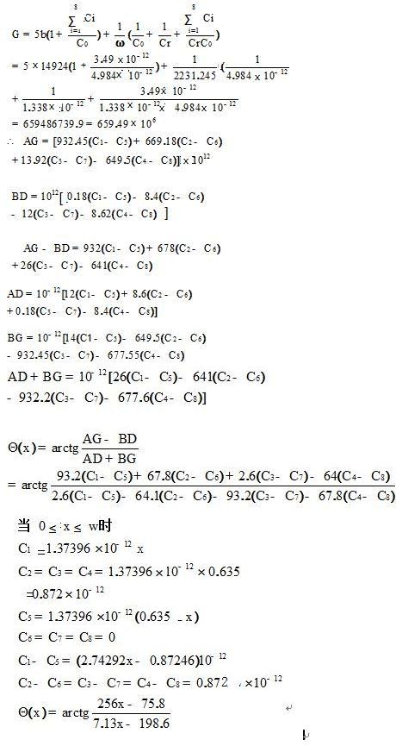

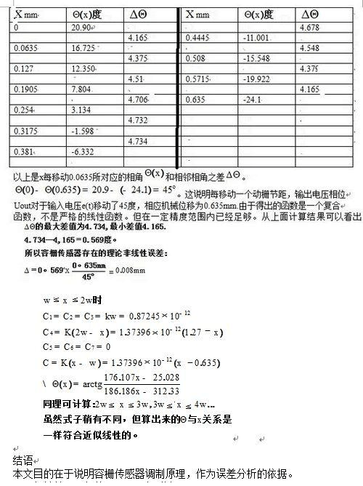

The conclusion is that the series pulse is generated by the clock pulse oscillator, and the AC voltage of the square wave and the sinusoidal function is generated by the processing, and the "carrier" is used as the modulation "carrier", and then to a series of capacitive grid, Value is affected by the mechanical displacement x, so the output of the AC signal voltage phase and displacement X was approximately linear relationship, and then through the conversion demodulation, as the displacement X liquid crystal display.

The non-linearity error of the displayed X value is about 0.008 mm.



(Finish)

Capacitive gate sensor

It has the advantages of small size, simple structure, high resolution and high accuracy, fast measurement speed, low power consumption, low cost, and low demand for other use of other digital displacement sensors such as gratings and inductive synchronizers. Of the characteristics, so in the electronic measurement technology occupies a very important position. As the measurement technology to the precision, high-speed, automation, integration, intelligent, economic, non-contact and multi-functional direction of the development of capacitive sensors more and more widely.

The system is mainly on the linear displacement measurement, so the use of linear capacitive sensor. The structure of the capacitive gate sensor is very similar to that of a parallel plate capacitor, which is formed by connecting a series of parallel plate capacitors arranged in a grid-like structure. If the periodic signal of the time-varying period is controlled by the electronic circuit, Different phase distributions are respectively loaded on the respective gate of the grid-like capacitor, the induced signal generated at any instant on the other common plate will have the same phase distribution as the momentarily loaded excitation signal.

(X), C2 (x), C3 (x) ... C8 (x) is the equivalent circuit of the block on the movable grid, and the equivalent circuit of the capacitor formed between the grid and the grid, And the corresponding stack on the grid formed by the capacitance, it is a function of displacement x, assuming that the small emitter plate and the reflective plate is fully covered when the capacitance between the two is C0, each small emitter plate width (X) = C 0 (x) = C 0, and C 1 (x) = C 2 (x) = C 3 (x) = C 0,

(X) = c0 (x) = c7 (x) = 0. It can be drawn that the capacitance between the two plates in the whole range varies with the displacement x.

When x is any value, there is always a part of the 48 pole plates on the movable grid to form a capacitor with "ground" (shield). The corresponding input source is directly connected to "ground" and does not affect the output signal of the sensor , But in order to derive φ (x) (φ (x) for the sensor output signal relative to a certain drive signal phase shift) with the amount of displacement x continuous change of the unified formula, in the derivation does not consider these plates on the "ground" Forming a capacitor, and still regard them as a fixed grid to form a capacitor, but at this time their capacitance is zero. Since these capacitances are zero, the impedance is infinite. The corresponding signal source all fall on these capacitors, the same, the sensor output signal has no effect.

If the transmission voltage V1 ~ V8 applied to each emitter plate of the grid sensor is 8-channel frequency and the amplitude is the same and the phase difference between adjacent small plates is π / 4, then the emitter There is a voltage Vf, there is a voltage Vr at the receiving pole. Application of AC circuit theory and Kirchhoff current law, interpretation of the equivalent circuit shown in Figure 1, as follows:

If Vo is used to denote the amplitude of each emitter voltage and the phase of the first signal in the 8-channel signal is the reference value,

Where φ0 is the phase angle of V1.

(X = (i = 1, 2, ..., 8) into the above two formulas

It can be seen that the output voltage of the capacitive gate sensor is a sinusoidal voltage with the same frequency as the emission voltage, and its amplitude changes in a very small range, which can be approximated as a constant, and the phase is ahead of π / 4 + φ (x) The Phase displacement φ (x) can be measured by phase-finding measurement circuit, you can get the relative displacement x, visible capacity sensor is a phase tracking type displacement sensor, the sensor is not sensitive to changes in the amplitude of the input signal, It has a good anti-interference ability.

In the whole measurement system, the main function of the capacitive sensor is to change the amount of mechanical displacement into the phase change of the electrical signal, and then sent to the measurement circuit for data processing. The capacitive gate sensor is controlled by the precision voltage comparator TLC354, which is powered by the relay. The CPU89C52 provides the required excitation signal and receives its induction signal. The phase difference between the excitation signal and the induced signal is measured by the phase detector circuit. Series of changes, you can get the length of the piston movement distance.

Capacitive gate sensor



It has the advantages of small size, simple structure, high resolution and high accuracy, fast measurement speed, low power consumption, low cost, and low demand for other use of other digital displacement sensors such as gratings and inductive synchronizers. Of the characteristics, so in the electronic measurement technology occupies a very important position. As the measurement technology to the precision, high-speed, automation, integration, intelligent, economic, non-contact and multi-functional direction of the development of capacitive sensors more and more widely.

The system is mainly on the linear displacement measurement, so the use of linear capacitive sensor. The structure of the capacitive gate sensor is very similar to that of a parallel plate capacitor, which is formed by connecting a series of parallel plate capacitors arranged in a grid-like structure. If the periodic signal of the time-varying period is controlled by the electronic circuit, Different phase distributions are respectively loaded on the respective gate of the grid-like capacitor, the induced signal generated at any instant on the other common plate will have the same phase distribution as the momentarily loaded excitation signal.

(X), C2 (x), C3 (x) ... C8 (x) is the equivalent circuit of the block on the movable grid, and the equivalent circuit of the capacitor formed between the grid and the grid, And the corresponding stack on the grid formed by the capacitance, it is a function of displacement x, assuming that the small emitter plate and the reflective plate is fully covered when the capacitance between the two is C0, each small emitter plate width (X) = C 0 (x) = C 0, and C 1 (x) = C 2 (x) = C 3 (x) = C 0,

(X) = c0 (x) = c7 (x) = 0. It can be drawn that the capacitance between the two plates in the whole range varies with the displacement x.

When x is any value, there is always a part of the 48 pole plates on the movable grid to form a capacitor with "ground" (shield). The corresponding input source is directly connected to "ground" and does not affect the output signal of the sensor , But in order to derive φ (x) (φ (x) for the sensor output signal relative to a certain drive signal phase shift) with the amount of displacement x continuous change of the unified formula, in the derivation does not consider these plates on the "ground" Forming a capacitor, and still regard them as a fixed grid to form a capacitor, but at this time their capacitance is zero. Since these capacitances are zero, the impedance is infinite. The corresponding signal source all fall on these capacitors, the same, the sensor output signal has no effect.

If the transmission voltage V1 ~ V8 applied to each emitter plate of the grid sensor is 8-channel frequency and the amplitude is the same and the phase difference between adjacent small plates is π / 4, then the emitter There is a voltage Vf, there is a voltage Vr at the receiving pole. Application of AC circuit theory and Kirchhoff current law, interpretation of the equivalent circuit shown in Figure 1, as follows:

If Vo is used to denote the amplitude of each emitter voltage and the phase of the first signal in the 8-channel signal is the reference value,

Where φ0 is the phase angle of V1.

(X = (i = 1, 2, ..., 8) into the above two formulas

It can be seen that the output voltage of the capacitive gate sensor is a sinusoidal voltage with the same frequency as the emission voltage, and its amplitude changes in a very small range, which can be approximated as a constant, and the phase is ahead of π / 4 + φ (x) The Phase shift φ (x)

Can be used to identify the phase measurement of the measured circuit, you can get the relative displacement x, visible capacitive sensor is a phase tracking type displacement sensor, the sensor is not sensitive to the amplitude of the input signal changes, it has a good resistance Interference ability.

In the whole measurement system, the main function of the capacitive sensor is to change the amount of mechanical displacement into the phase change of the electrical signal, and then sent to the measurement circuit for data processing. The capacitive gate sensor is controlled by the precision voltage comparator TLC354, which is powered by the relay. The CPU89C52 provides the required excitation signal and receives its induction signal. The phase difference between the excitation signal and the induced signal is measured by the phase detector circuit. Series of changes, you can get the length of the piston movement distance.

Translated with google translate from:

<http://www.chinadmd.com/file/z3pc6wruevzvtr6t6cu6owra_1.html>